Assignment # 53-57 JAVASCRIPT

**Events**

1. Consider you have 4 images in a file as shown below:

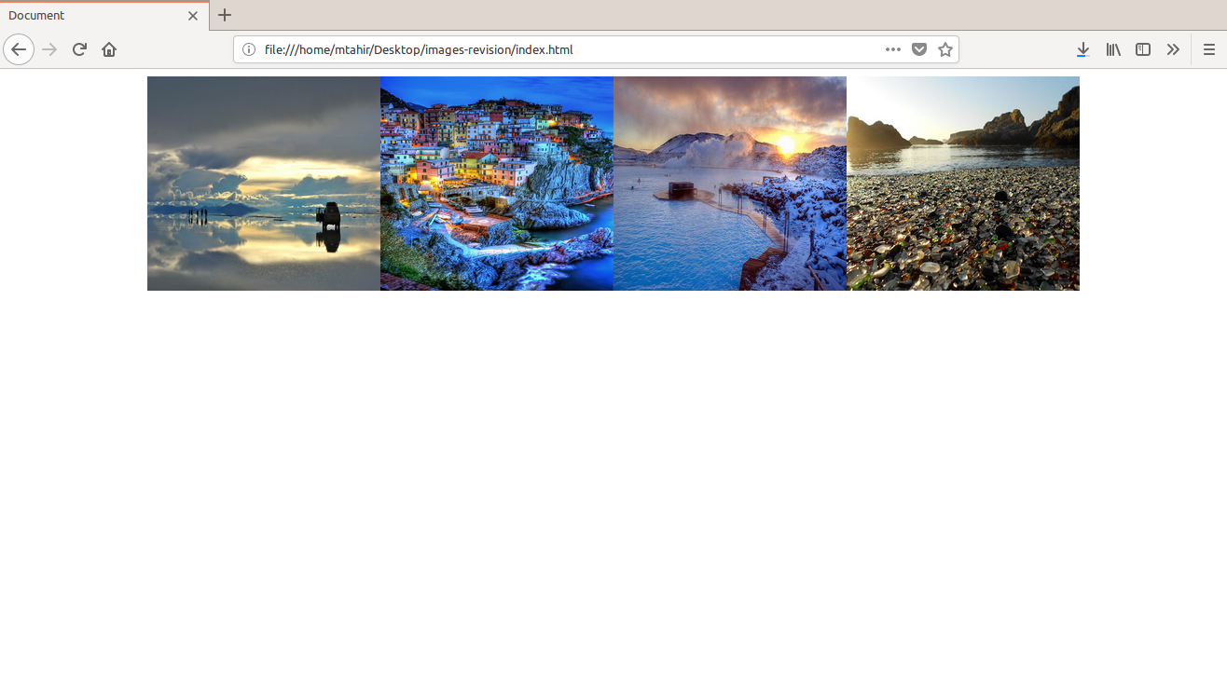

Now When you click on an image it should display in a modal.

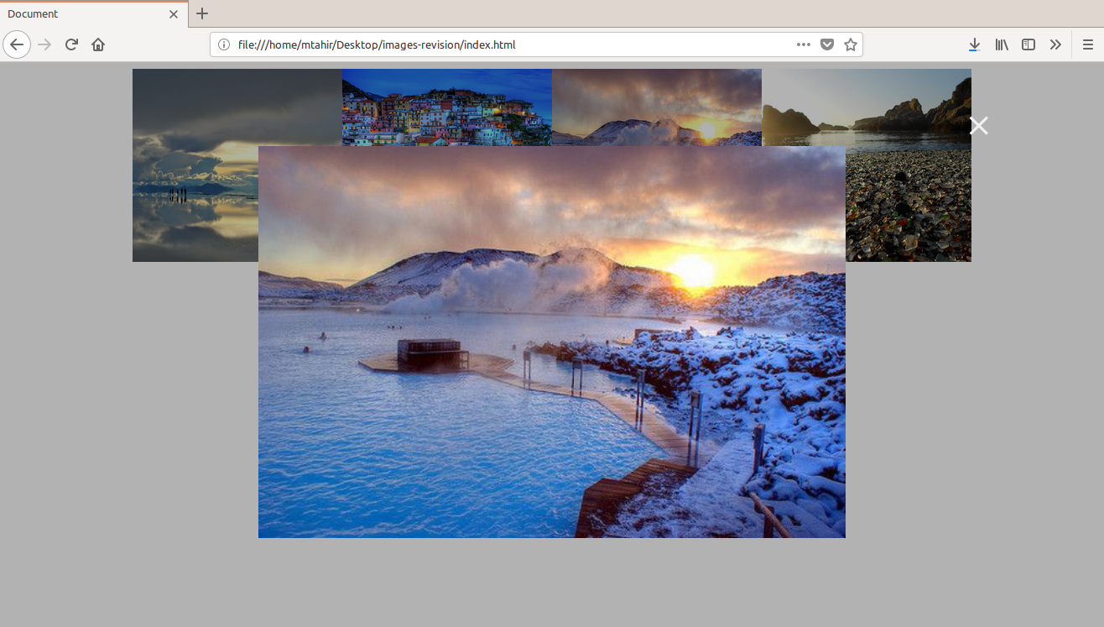

**Modal code is available in this assignment file**.

2. Create a paragraph and two buttons “zoom in ”(+) and “zoom out”(-).

On each click on “zoom in”(+) , add 10px in font size of paragraph.

And on each click on “zoom out”(-) , minus 10px in font size of paragraph.